Prompt: Why did many Americans adopt a nativist policy towards immigration in the 1890s?

Source A: “The Racial Basis of European History” Madison Grant, 1916.
The book was reprinted throughout the early 1920s and was a bestseller both in the United States, as well as in Northern Europe.

These new immigrants were no longer exclusively members of the Nordic Anglo-Saxon race as were the earlier ones who came...the new immigrants contain a large number of the weak, the broken, and the mentally crippled of all races drawn from the lowest levels of the Mediterranean basin, together with hordes (crowds) of the wretched (suffering), submerged populations of the Polish Ghettos (Jews). Our jails, insane asylums, and almshouses (homeless shelters) are filled with this human flotsam (wreckage) and the whole tone of American life, social, moral, and political has been lowered and vulgarized by them.

Source B: P.V. Gillam, Cartoon, Judge, 1890.
“Judge” was a humor magazine published throughout the late 19th and early 20th century. It supported the Republican party of the time. Note: “indiscriminate” means “unlimited”. “Pauper” means “poor”.
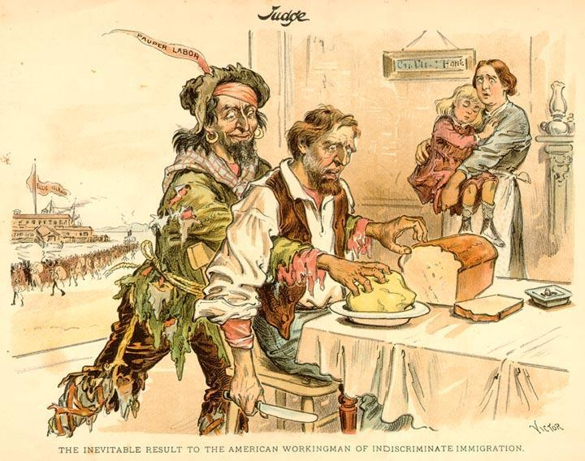

Source C: Speech to the U.S. Senate, Senator Henry Cabot Lodge, 1891.
The statement was made during a debate over the proposed Literacy Act of 1891 that would have restricted future American immigration to those who could read and write.

What makes a race are their mental and, above all, their moral characteristics, the slow growth and accumulation of centuries of work and conflict. These are the qualities which determine their social success as a people, which make one race rise and another fall. It is on the moral qualities of the English-speaking race that our history, our victories, and all our future rest. There is only one way in which you can lower those qualities or weaken those characteristics and that is by breeding them out. If a lower race mixes with a higher in sufficient numbers, history teaches us that the lower race will prevail (succeed). The lower race will absorb the higher, not the higher the lower, when the two strains approach equality in numbers. We are exposed to but a single danger, and that is by changing the quality of our race and citizenship through the wholesale infusion of races whose tradition, whose thoughts and whose beliefs are wholly alien to ours…

Source D: “Our Country” Josiah Strong, 1885.

...immigration not only provides our country with most of its criminals, it is also seriously affects the morals of the native population. It is disease and not health which is contagious. Most foreigners bring with them continental ideas of the Sabbath, and the result is sadly manifest in all our cities, where it is being transformed from a holy day into a holiday. But by far the most effective instrumentality for corrupting popular morals is the liquor traffic, and this is chiefly carried on by foreigners…

Source E: President Grover Cleveland, Veto of the Literacy Test, 1897
A bill for a literacy test finally passed Congress in 1897, which Democratic President Cleveland then vetoed. Here he explains why he vetoed the bill.

It is said that the quality of recent immigration is undesirable. The time is quite within recent memory when the same thing was said of immigrants who, with their descendants, are now numbered among our best citizens.

The claim is also made that the influx of foreign laborers takes away the opportunity to work. An unfortunate condition is certainly presented when any who are willing to labor (work) are unemployed, but so far as this condition now exists among our people, it must be conceded (admitted) to be a result of awful business depression and the stagnation (sluggishness) of all businesses. With the implementation of my economic governmental policies, the misfortunes of unemployed labor should be remedied (fixed)…

