Westward Expansion and The Homestead Act:
Guided Notes
America in ________:
- No major _____________________ went West
- Traveling West was extremely ____________ and ____________________– 2-3 Months by land (Native American Resistance)
- ________ Months by boat, All the way around _________________________
Westward Expansion
Factors that Contributed to Westward Expansion:
- __________________________________
- _____________ Discovered in California
- Homestead Act of ____________
- Transcontinental ____________________
- The ______________________________________
Manifest ____________:
- The west was viewed as the great untapped _________________
- Manifest Destiny: Americans believed it was their _____________________ duty to conquer the Western territories and unify the Nation spreading _____________and ________________
Territorial Expansion of the U.S.:
- 1803 ___________________________
- ______ Texas
- 1848 _______________________________________: Colorado, Arizona, New Mexico, Wyoming, California, Nevada, and Utah
- By 1850, America gains the ____________ Territory
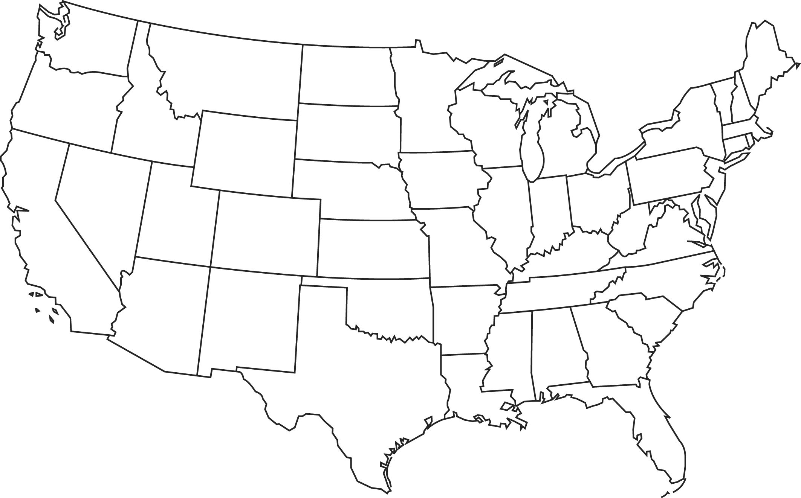
Gold Rush & the American Dream:
- ________ Gold Discovered in California
- Thousands of Americans head West lured by the idea of becoming __________________ ________________
The Oregon Trail:
- The only way West by land was via the _________________
- ____________ route
- Dangerous and __________ /Donner Party
The Homestead Act
The Homestead Act of 1862:
- The U.S. Government _________________________________ of the West
- 1862 Homestead Act: Millions of _____________were given away free in the West to anyone that would claim land and live on it for ______ years. Requirements:
  - ____ Years Old
  - Head of __________________
  - American _________________
- ___________________________ basis
- Could purchase up to ______________________
- Other Public land was sold for ________ an ________

